How to make database upgrade scripts executable from within the Opus application

There are no constraints on the SQL scripts themselves (except that no semicolons can be used within SQL comments). Existing SQL scripts can be displayed and executed in the “Database upgrade” view by following these steps.

Write database script
The database script shall be located in the module’s database folder, e.g. /college/database/version34_version40/34_100_opuscollege_update.sql.
The database script needs to update the module version in the appConfig table, so that scripts don’t get executed more than once if successful:
-------------------------------------------------------
-- table appVersions
-------------------------------------------------------
UPDATE opuscollege.appVersions SET dbVersion = 3.63 WHERE lower(module) = 'college';

-------------------------------------------------------
-- here come the sql statements of this script

[…]
Table 1: Setting the module’s database version in the database script
The module’s database version will only be written to the appVersion table if the script runs successful. Otherwise the transaction is rolled back and no changes are made to the database at all.

Add database upgrade tags
In applicationContext-module.xml, add a bean for each database upgrade. See the following example for database upgrade 3.63 in the college module. Note that the order in which upgrades will be executed is defined by the “order” property. The order property is normally best based on the date on which the upgrade was written.

<bean id="collegeModule" class="org.uci.opus.college.module.Module">
[...]
</bean>

<bean name="college-3.63" class="org.uci.opus.util.dbupgrade.SqlFileUpgradeCommand">
<property name="sqlFile" value="classpath:../database/version34_version40/34_100_opuscollege_update.sql"/>
<property name="dataSource"><ref bean="dataSource" /></property>
<property name="order" value="2012-06-18 10:30" />
<property name="module" ref="collegeModule" />
<property name="version" value="3.63" />
</bean>
Table 2: The definition of a database upgrade for the college module
Note that the key of the “dbUpgrades” map corresponds to the version to which the SQL scripts will upgrade. This version needs to be the same as the one that is set by the SQL scripts in the “appVersions” table entry for the module.

Verify / run in the database upgrade view
Start the Opus application, log in and choose “database upgrades” from the admin menu (see illustration). The view will show a list of available upgrades, sorted in the order they are supposed to be executed.
Select the upgrades that shall be executed and click “Run”. Normally, all upgrades shall be executed in a single run; this will execute all upgrades in a single transaction, so either all upgrades execute with success or will rolled back.
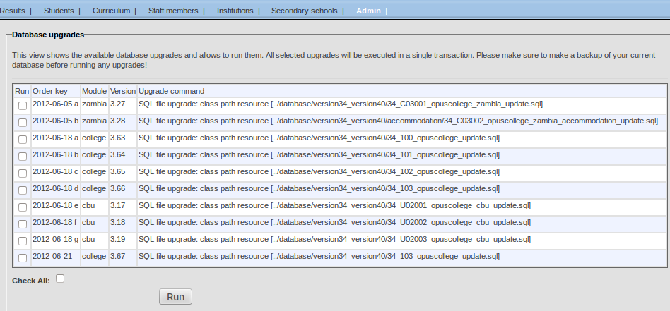Illustration 1: The database upgrade view

Trouble shooting

Bad SQL grammar because of the use of semicolon in the license text
SQL file comments must not have semicolon (;) characters. Otherwise, SQL files cannot be executed through the dbUpgrade facility. Therefore, the license text must not include the semicolon. Replace the semicolon with a different character, e.g. a normal comma (,).
bad SQL grammar [/******************************************************************************* * ***** BEGIN LICENSE BLOCK ***** * Version: MPL 1.1/GPL 2.0/LGPL 2.1 * * The contents of this file are subject to the Mozilla Public License Version * 1.1 (the "License")]; nested exception is org.postgresql.util.PSQLException: ERROR: unterminated /* comment at or near "/******************************************************************************* * ***** BEGIN LICENSE BLOCK ***** * Version: MPL 1.1/GPL 2.0/LGPL 2.1 * * The contents of this file are subject to the Mozilla Public License Version * 1.1 (the "License")" Position: 1
Tabelle 1: Error message when using semicolon in the license text

